  
 ***PROJECT REPORT***  
  
**COURSE TITLE : Compiler Lab**  
**COURSE CODE : CSE 352**  
  
 **SUBMITTED TO :  
 Md. Tasnin Tanvir  
 Lecturer,  
 Department of Computer Science and Engineering  
 University of Information Technology & Sciences  
 ( UITS )**  
 **SUBMITTED BY :  
 NAME : Tonny Talukder**

**ID Number : 0432220005101050**

**Section : 6A1**

**Batch : 52**   
 **Department : CSE**  
  
 ***DATE OF SUBMISSION*** ***: 26/05/2025*TONNYLang – A Custom Programming Language**

**1. Objective**

**To create a fictional programming language called TONNYLang that uses Bengali-style names for common programming functions. This is intended to help beginners relate better with programming logic in their own language.**

**2. Introduction**

**TONNYLang is a beginner-friendly language wrapper built on C++ syntax but with function and control structure names adapted to Bengali words. It provides a cultural and linguistic bridge for new learners to understand programming concepts more easily.**

**3. Language Design**

**A total of 25 essential programming concepts were translated into Bengali-style keywords. Here are some examples:**

|  |  |  |
| --- | --- | --- |
| **Serial** | **Original Function** | **TONNYLang Name** |
| **1** | **sum** | **Jogkoro** |
| **2** | **sub** | **komao** |
| **3** | **mul** | **Gunkoro** |
| **4** | **div** | **vagkoro** |
| **5** | **print** | **dekhao** |
| **6** | **input** | **nau** |
| **7** | **if** | **jodi** |
| **8** | **else** | **nahole** |
| **9** | **for** | **protibar** |
| **10** | **while** | **jotokkhon** |
| **11** | **switch** | **poriborton** |
| **12** | **case** | **obostha** |
| **13** | **break** | **thamao** |
| **14** | **continue** | **cholteythako** |
| **15** | **function** | **kajkoro** |
| **16** | **return** | **ferotkoro** |
| **17** | **import** | **niyeaso** |
| **18** | **class** | **dhoron** |
| **19** | **try** | **cheshtakoro** |
| **20** | **catch** | **dhoro** |
| **21** | **throw** | **churedao** |
| **22** | **true** | **shotti** |
| **23** | **false** | **mittha** |
| **24** | **and** | **ebong** |
| **25** | **or** | **othoba** |

#### **4. Tools Used**

* **Language: C++**
* **IDE: Code::Blocks**
* **File Structure:**
  + **main.cpp – Main file using TONNYLang functions**
  + **new.h – Header file with all custom-defined functions**

**5. Implementation**

**File: main.cpp  
This file takes two inputs from the user and performs:**

* **Addition (Jogkoro)**
* **Subtraction (komao)**
* **Multiplication (Gunkoro)**
* **Division (vagkoro)**

**Also demonstrates:**

* **if-else (jodi-nahole)**
* **for, while loops (protibar, jotokkhon)**
* **switch-case (poriborton, obostha)**
* **class (dhoron)**
* **try-catch-throw (cheshtakoro, dhoro, churedao)**

**CODE :**  
**1. main.cpp**

**#include<bits/stdc++.h>**

**#include "new.h"**

**using namespace std;**

**int main() {**

**dekhao("TONNYLang e tomar shagotom!");**

**dekhao("Doya kore duita songkha dao:");**

**int a = nau();**

**int b = nau();**

**int jog = Jogkoro(a, b);**

**int biyog = komao(a, b);**

**int gun = Gunkoro(a, b);**

**int vag = vagkoro(a, b);**

**dekhao("Jogfol: " + to_string(jog));**

**dekhao("Biyogfol: " + to_string(biyog));**

**dekhao("Gunfol: " + to_string(gun));**

**dekhao("Vagfol: " + to_string(vag));**

**if (a > b) {**

**dekhao("a b theke boro");**

**} else {**

**dekhao("nahole b boro");**

**}**

**dekhao("Protibar loop:");**

**for (int i = 1; i <= 3; i++) {**

**cout << "protibar: " << i << endl;**

**}**

**int c = 0;**

**dekhao("Jotokkhon loop:");**

**while (c < 3) {**

**cout << "jotokkhon: " << c << endl;**

**c++;**

**}**

**int d = 2;**

**switch (d) {**

**case 1:**

**dekhao("obostha 1");**

**break;**

**case 2:**

**dekhao("obostha 2");**

**break;**

**default:**

**dekhao("konobosthai nai");**

**}**

**for (int i = 0; i < 5; i++) {**

**if (i == 2) continue;**

**cout << "cholteythako: " << i << endl;**

**}**

**int result = kajkoro(4);**

**dekhao("kajkoro result: " + to_string(result));**

**cout << "ferotkoro: " << ferotkoro(result) << endl;**

**dhoronManush amr;**

**amr.nam = "Tonny";**

**amr.boyosh = 21;**

**amr.infoDekhao();**

**cheshtakoro_dhoro_example();**

**bool shotti = true;**

**bool mittha = false;**

**if (shotti && !mittha) {**

**dekhao("Eta shotti ebong mittha noy.");**

**}**

**if (shotti || mittha) {**

**dekhao("Eta shotti othoba mittha.");**

**}**

**return 0;**

**}**  
  
  
**2. new.h**

**#ifndef NEW_H**

**#define NEW_H**

**#include<bits/stdc++.h>**

**using namespace std;**

**// 1. sum -> Jogkoro**

**int Jogkoro(int a, int b) {**

**return a + b;**

**}**

**// 2. sub -> komao**

**int komao(int a, int b) {**

**return a - b;**

**}**

**// 3. mul -> Gunkoro**

**int Gunkoro(int a, int b) {**

**return a * b;**

**}**

**// 4. div -> vagkoro**

**int vagkoro(int a, int b) {**

**if (b != 0) return a / b;**

**else {**

**cout << "0 diye vag kora jabena!" << endl;**

**return 0;**

**}**

**}**

**// 5. print -> dekhao**

**void dekhao(string msg) {**

**cout << msg << endl;**

**}**

**// 6. input -> nau**

**int nau() {**

**int x;**

**cin >> x;**

**return x;**

**}**

**// 15. function -> kajkoro**

**int kajkoro(int x) {**

**return x * x;**

**}**

**// 16. return -> ferotkoro**

**int ferotkoro(int x) {**

**return x;**

**}**

**// 19, 20, 21: try-catch-throw**

**void cheshtakoro_dhoro_example() {**

**try {**

**throw runtime_error("Chure dao error paoa gese!");**

**}**

**catch (exception &e) {**

**cout << "Dhoro: " << e.what() << endl;**

**}**

**}**

**// 18. class -> dhoron**

**class dhoronManush {**

**public:**

**string nam;**

**int boyosh;**

**void infoDekhao() {**

**cout << "Nam: " << nam << ", Boyosh: " << boyosh << endl;**

**}**

**};  
  
#endif**

**OUTPUT :**  
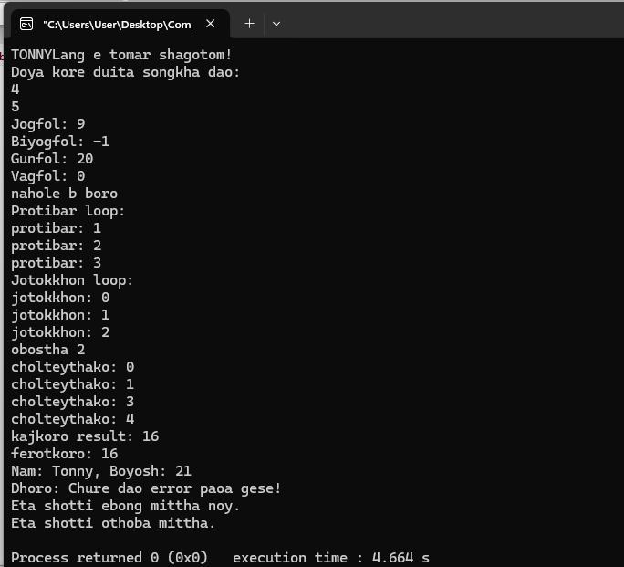  
  
  
  
 **7. Conclusion**

**TONNYLang successfully demonstrates how programming fundamentals can be localized for better understanding. This fictional language builds a meaningful bridge between logic and native language for first-time programmers. It can be extended further to include arrays, recursion, file handling, etc.**